Consumption and Revenue Analysis
Toronto, Atlanta and New York Area

January 1, 2001 to June 30, 2002

Version 1.0 – July 12, 2002
Data Management

Table of Contents

1.0 Introduction 3
2.0 Metrics Definition 3
2.1 Revenue 3
2.2 Paid Minute Consumption 3
2.3 Free Minute Consumption 3
3.0 Findings – Toronto 4
3.1 Male Revenue to Male Paid Minute Consumption 4
3.2 Male Paid Minute to Male Free Minute Consumption 5
4.0 Findings – Atlanta 6
4.1 Male Revenue to Male Paid Minute Consumption 6
4.2 Male Paid Minute to Male Free Minute Consumption 7
5.0 Findings – New York City Area 8
5.1 Male Revenue to Male Paid Minute Consumption 8
5.2 Male Paid Minute to Male Free Minute Consumption 9

1.0 Introduction

This document contains a summary of the Revenue and Consumption Analysis undertaken by Data Management as part of the IVR Task Force.

18 months of data were examined between January 1, 2001 and June 30, 2002.

2.0 Metrics Definition

2.1 Revenue

Revenue is calculated as total Male Revenue converted to Canadian Dollars (using Budgeted exchange rates).

Revenue from 900 customers and customers purchasing the 7 day Unlimited price block (end of June 2002) are not included.

2.2 Paid Minute Consumption

Paid Minute Consumption is calculated as the total number of Paid Male minutes consumed on the IVR.

Paid Minute Consumption does not include 900 customers or customers consuming minutes associated from 7 day Unlimited price block sales.

2.3 Free Minute Consumption

Free Minute Consumption is calculated as the total number of Male minutes consumed on the IVR minus the total number of Paid Male minutes consumed on the IVR (see section 2.2).

Free Minute Consumption does not include free minutes consumed by 900 users but does include Paid Minutes consumed by Unlimited price block users which has a minimal affect for the last 2 weeks of the report.

3.0 Findings – Toronto

3.1 Male Revenue to Male Paid Minute Consumption

We found that Paid Minute Consumption tracked vary closely to Sales in Toronto over the 18 month period with an average of one (1) paid minute consumed for every $0.48 of sales.

The following graph shows the weekly trend in Toronto over the 18 month period.

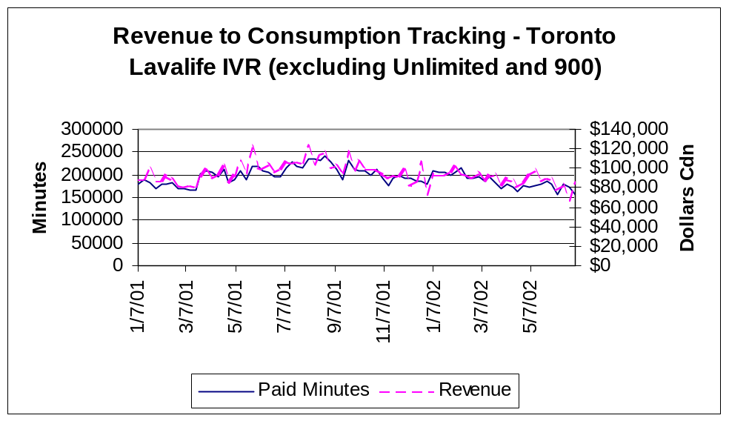

3.2 Male Paid Minute to Male Free Minute Consumption

We found the ratio between Paid Male Minutes and Free Male Minutes to be consistent for Toronto over the 6 month period with an average of 22% of all Male Minutes consumed being Paid Minutes.

The following graph shows the weekly trend in Toronto over the 6 month period.

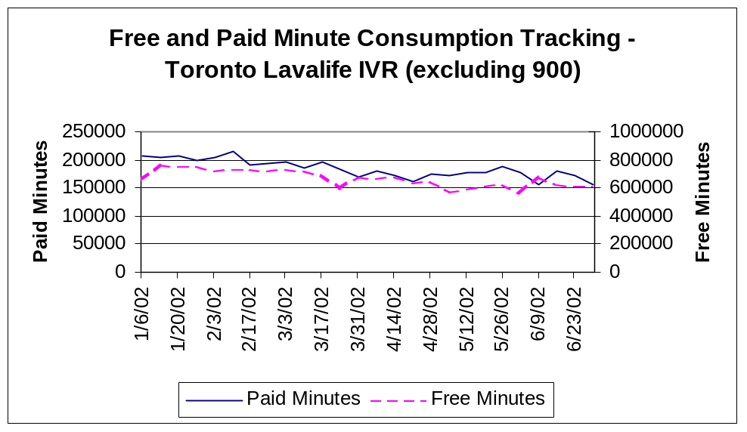

Findings – Atlanta

4.1 Male Revenue to Male Paid Minute Consumption

We found that Paid Minute Consumption tracked vary closely to Sales in Atlanta over the 18 month period with an overall average of one (1) paid minute consumed for every $0.60 of sales.

This ratio changes slightly between January 2002 and March 2002 to one (1) paid minute consumed for every $0.53 in sales. This may be due to Promotions executed in Atlanta during this time period.

The following graph shows the weekly trend in Atlanta over the 18 month period.

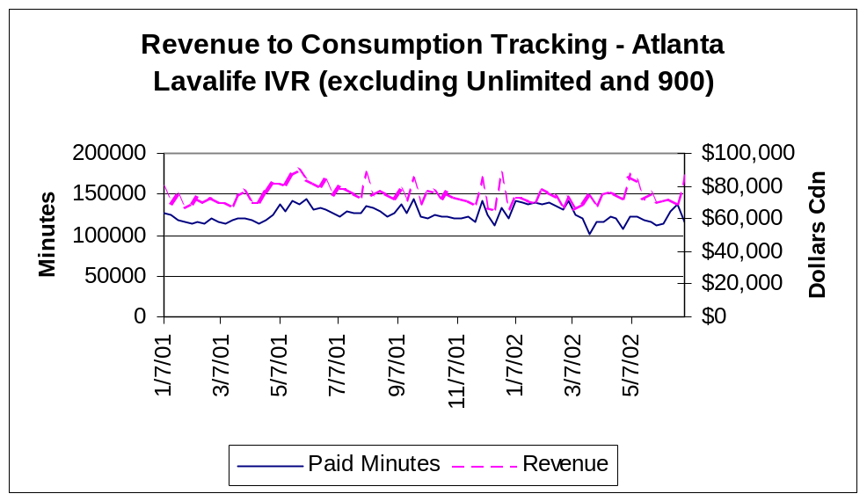

4.2 Male Paid Minute to Male Free Minute Consumption

We found the ratio between Paid Male Minutes and Free Male Minutes to be consistent for Atlanta over the 6 month period with an average of 18% of all Male Minutes consumed being Paid Minutes.

The following graph shows the weekly trend in Atlanta over the 6 month period.

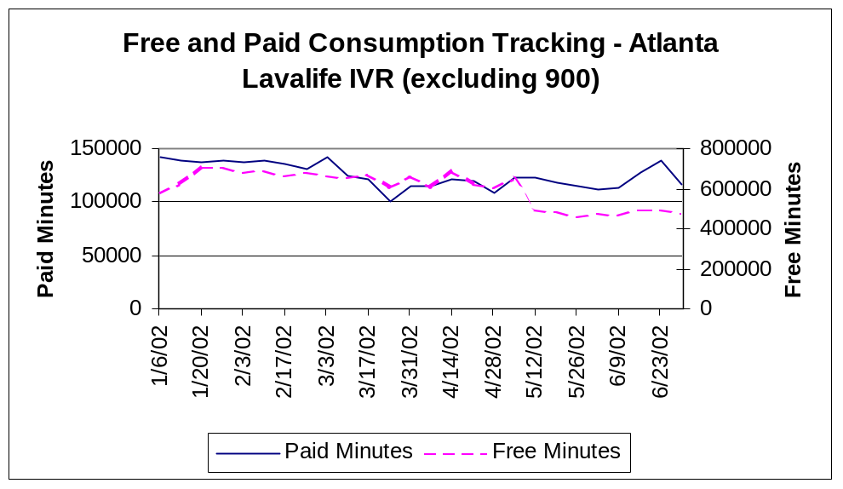

Findings – New York City Area

The New York City Area IVR results include the following cities:

NEWARK
NEW HAVEN
NEW YORK
LONG ISLAND
BERGEN
WESTCHESTER

5.1 Male Revenue to Male Paid Minute Consumption

We found that Paid Minute Consumption tracked vary closely to Sales in New York over the 18 month period with an overall average of one (1) paid minute consumed for every $0.54 of sales.

This ratio changes slightly between January 2002 and March 2002 to one (1) paid minute consumed for every $0.46 in sales. This may be due to Promotions executed in New York during this time period.

The following graph shows the weekly trend in New York over the 18 month period.

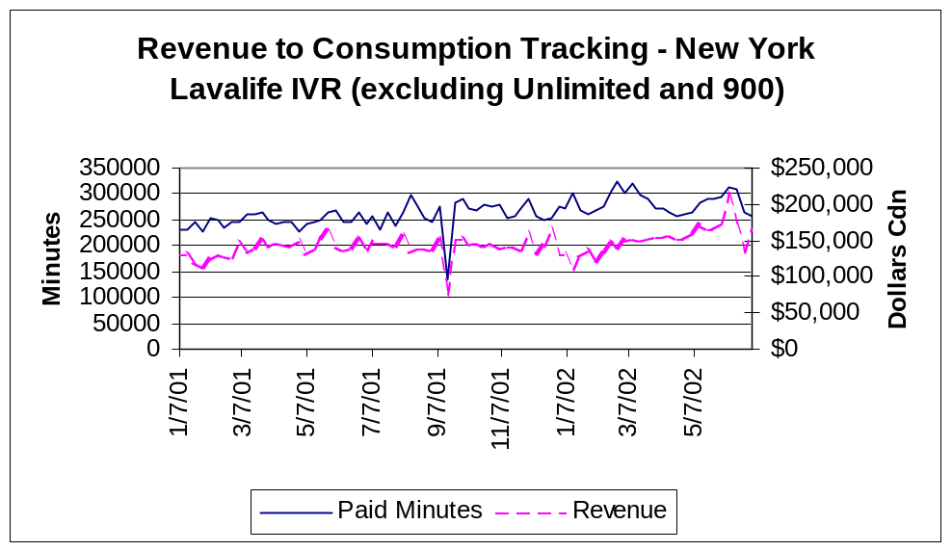

5.2 Male Paid Minute to Male Free Minute Consumption

We found the ratio between Paid Male Minutes and Free Male Minutes to be consistent for New York over the 6 month period with an average of 27% of all Male Minutes consumed being Paid Minutes.

An anomaly was found in the Free Minute data which was identified as a known X2K logging bug. This error was corrected in April 2002. No adverse effect on system performance or sales occurred during the affected time period.

The following graph shows the weekly trend in New York over the 6 month period.

